Water World I
Time Limit: 1000 mSec Memory Limit : 32768 KB
Problem Description
The well known PC game engineer Kevin Flynn designed a new game:Water World I.Player can enters the Virtual World and build the world through this game.
Jack is the Administrator of Virtual World.He is responsible for water conservation project.Now Kevin gives him an important mission:building a reservoir made with thousands of moutain.
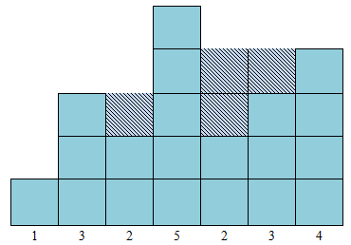
The design chart of reservoir is very simple.every mountain's width is 1 unit and the hight is Hi numbered from left to right.The valley between two moutains can hold water.
After the project had been finished,the Virtual World War I broken out.The reservoir is affected by the war,it become tilt.Jack want to know how much water can it hold now.
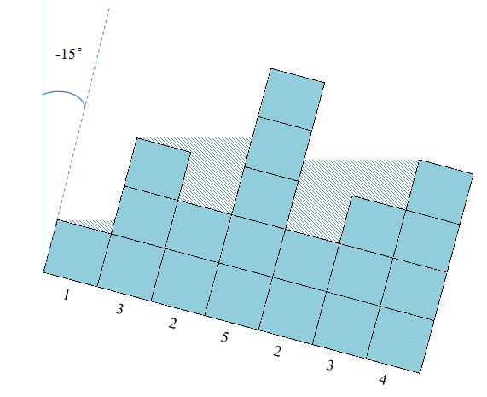
Input
The input consists of several test cases.
For each case,there are two number n,angle in first line.(0<n<=10000,0.0<=|angle|<=80.0).
when it tilt toward left,angle>0,otherwise,angle<=0.
Then follow one line there are n integers indicate that the ith monutain's height is Hi.the mountain starts from left to right.(0<Hi<100000)
Output
For each case print a real number,indicate the maxmum of water it can hold. Your answer must be rounded to 2 digits after the decimal point.
Sample Input
3 0.0
2 3 1
7 -15.0
1 3 2 5 2 3 4
Sample Output
1.00
4.13

